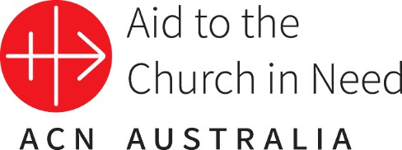

Media Release 01.02.2021

National Prayer Campaign Breaks New Record – Over 2000 Masses have been arranged to pray for the multitude of needs surrounding the COVID-19 situation, in turn, helping poor priests to survive.
As Australia notes the one year anniversary of the first case of Covid-19, Aid to the Church in Need Australia thanks the Catholic people of Australia who collectively arranged over 2000 Masses for the needs of the nation during the pandemic. As soon as it became clear that Australia was going to be deeply affected by the virus ACN Australia moved to prepare, print and distribute thousands of prayer cards across the country imploring Catholics to arrange Masses which at the same time support poor priests around the world.
One hundred percent of every Mass offering (or Mass stipend) donated is distributed to poor priests overseas who offer Mass for the intention of the benefactor. Mass offerings are what provide existential support to ten percent of the world’s priests today. These Mass offerings have become even more crucial in those regions that were already struggling prior to the coronavirus pandemic due to poverty or persecution.

The national office of ACN Australia launched the prayer campaign as the devastating effects of the COVID-19 pandemic on the suffering Church were being made apparent. ACN International had received multiple requests from Bishops in India, Bangladesh, Burkina Faso, Nigeria, Venezuela and other countries who were asking for assistance in the form of Mass offerings on behalf of their priests. These priests were struggling to provide for themselves in their parishes due to the COVID-19 restrictions forcing Churches across the globe to shut their doors.
Often priests serving in poor and remote areas rely on what the local parishioners put in the collection plate in order to survive. However, without the community gathering for Mass and sharing what they have as an offering (in some areas the offering is as simple as a few eggs, a bunch of bananas or a cup of rice), the priests are concerned where their next meal will come from.

In response, ACN Australia created a national prayer campaign asking people to add to a spiritual bouquet of Masses praying for the multitude of needs surrounding the coronavirus. So far the spiritual novena has reached over 2000 Masses that have been offered for the intentions surrounding COVID-19. This amounts to almost AUD $30,000 in Mass stipends which will be sent to priests in their communities who often use the Mass stipend not only to support themselves but the vulnerable within the community who look to them for assistance. In arranging a Mass many of ACN's benefactors recognise the profound spiritual purpose of uniting their charity with church prayers.
In 2020 a total of 1,782,097 Holy Masses were celebrated for the intentions of ACN benefactors which supported about every ninth priest world-wide.

To add to ACN's spiritual bouquet of Masses visit: www.aidtochurch.org/coronavirus

MEDIA INQUIRIES:

Contact:
Teresa Hodal
Communications Coordinator – Aid to the Church in Need
E: media@aidtochurch.org P: (02) 9167 9517 (direct) www.aidtochurch.org

